Michael Gontarek

CS 499 Computer Science Capstone

Southern New Hampshire University

August 2, 2022

5-2 Milestone Four: Enhancement Three: Databases

The artifact being used is from my SQL class. This project was created throughout the class and submitted at the end as the final project. I chose this artifact because it shows that I can create and manipulate data within tables. I took tables from my SQL class and changed the table names and columns as well as the types of data the columns stored. This artifact also shows that I can solve problems by sorting, manipulating, and accessing certain data. To improve this artifact, I changed the tables to reflect the Minnesota Wild hockey team. I added the players and their statistics into the updated table and columns. From there I used inner joins, ordering the goal column, and added the goals and assists columns to create a points column. This shows that I was able to use innovative skills and techniques for implementing database solutions to accomplish the goals I set out to achieve. I also took certain players from different countries and added up the goals they produced collectively.

I did everything I wanted to do when looking forward to this artifact. I have no plans to update or change this project. Later down the road I may add the rest of the team and maybe make a table for the goalies. As far as this class goes, I do not plan on adding more to this project.

I learned quite a bit during the completion of this project. I learned more about Oracle Live SQL and how it worked. I learned more in-depth how joins worked as well as how to pull the data I wanted when working with joins. Ordering data that was in a database was also cool to learn and use since I did not use that in my class. The things I got most excited about learning were how to add all the data in a column to get a total as well as adding two columns and creating a new column with that result. The biggest challenge I had was learning the Live SQL application and how to navigate the system. I also struggled for a little while when it came time to get the points column to translate into the tables with players from certain countries. This was the most rewarding challenge to work through and get the desired result as it showed that I can manipulate data to access the information needed.

Attached at the bottom are some of the statements that were made to create change and manipulate the data.

1. Doing an inner join from two tables (WildPlayers and HOMETOWNS). Hometowns had the players jersey number, city, and country. The goal was to add goals and assists to see where the players were from along with their scoring production. This also allowed me to get statements regarding goals per country.

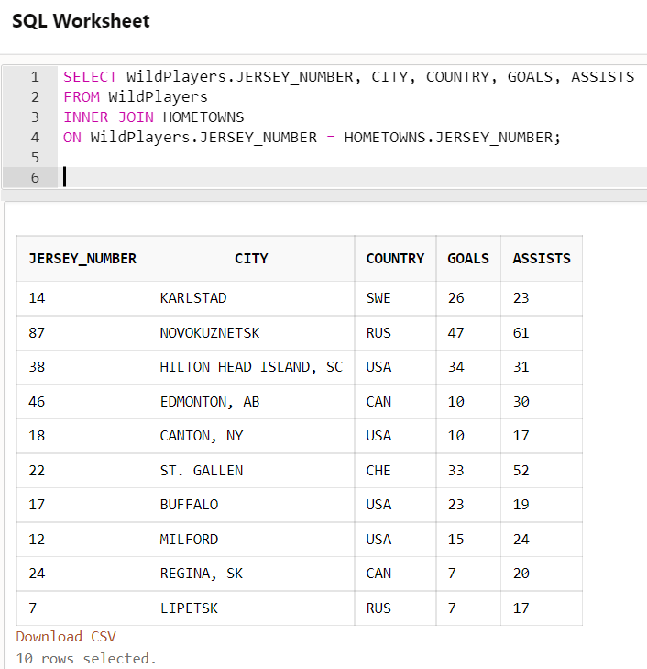

1. This was to get the sum of the goals column and display the answer as total goals.

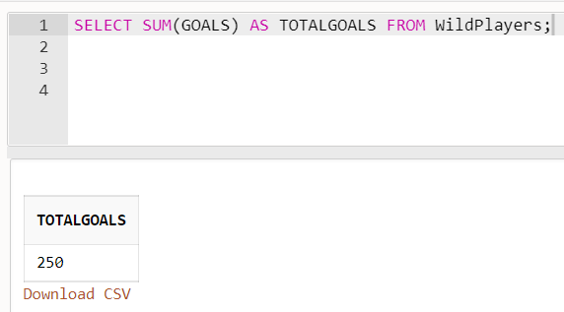

3. Get the total number of goals scored by Canadian players.

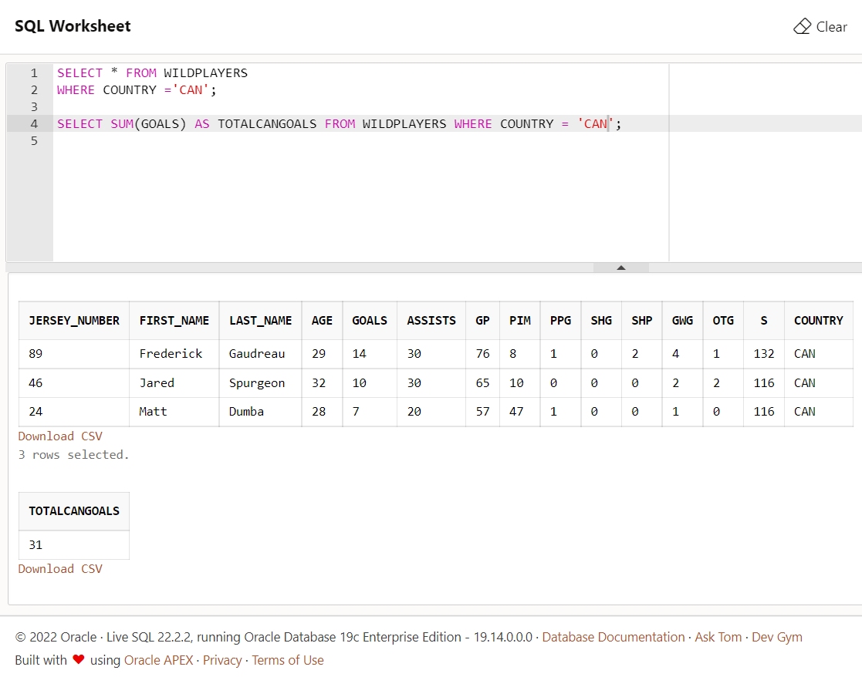

1. Get the total number of goals scored by Russian players.

1. Get the total number of goals scored by United States players.

1. Gets the sum of goals and assists and creates a column called points.

